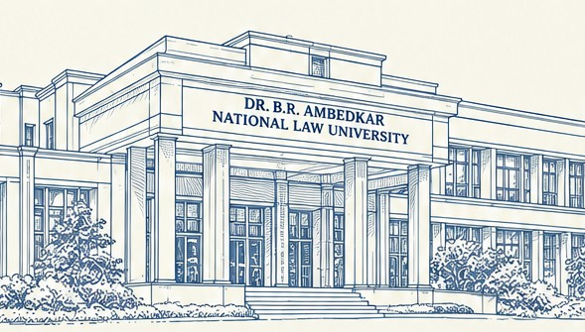

Dr. B. R. Ambedkar National Law University, Sonepat
IPR Facilitation and Research Centre
In collaboration with K&S PARTNERS
organises



NATIONAL CONFERENCE
on
Emerging Trends in Trade Mark
Protection in India: Legal Enforcement and Challenges

31 October 2026 Hybrid Mode

Table of Contents

- About Dr. B. R. Ambedkar National Law University

- About the IPR Facilitation and Research Centre

5

6

7

8

9-11

12

13

14

15

16

17

18

19
About K&S Partners

Message from Vice - Chancellor Message from Director Message from Co - Director
About the Conference

Themes and Sub - Themes Aims and Objectives
Submission and Registration Process

Guidelines for Submission Abstract Submission Registration Fees
Awards and Recognition Timeline

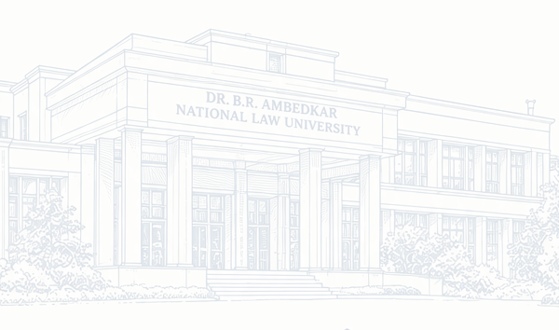20 Contact Us

IPR Facilitation & Research Centre | Page 2

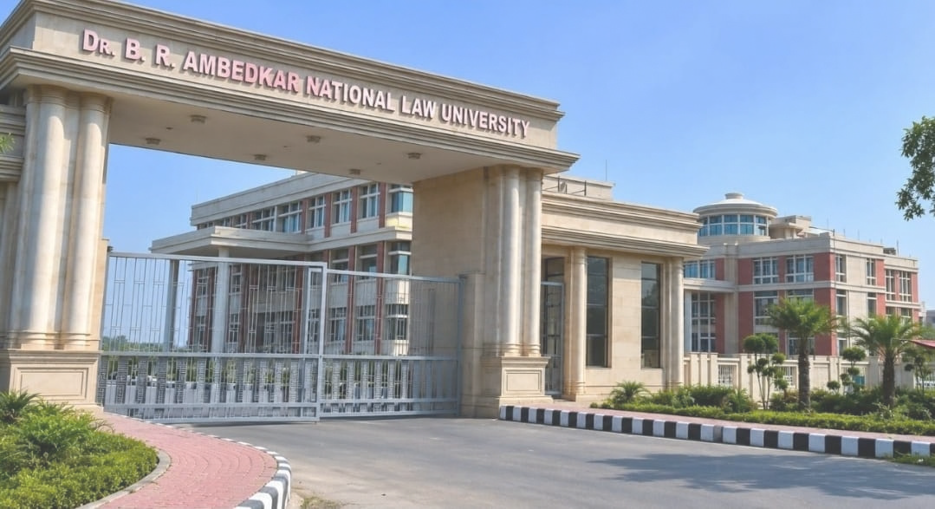About Dr. B. R. Ambedkar National Law University

Dr. B.R. Ambedkar National Law University, Sonepat, established by the State Government of Haryana in 2019 through State Legislature Act No. 15, stands as a premier institution reflecting India's commitment to justice and constitutional values. Strategically located with excellent connectivity to Delhi, the University offers B.A. LL.B. (Hons.), B.B.A. LL.B. (Hons.), LL.M., and Ph.D. programmes, providing a comprehensive legal education that combines academic rigour with ethical and social awareness.

The University houses eleven specialised research centres, three dedicated cells, and a Legal Aid Clinic, fostering holistic legal education and community engagement.

Guided by Hon'ble Chancellor Prof. Ashim Kumar Ghosh, Hon'ble Governor of Haryana, and Hon'ble Visitor Mr. Justice Surya Kant, Hon'ble Chief Justice of India, the University continues its pursuit of academic excellence and social relevance.

IPR Facilitation & Research Centre | Page 3

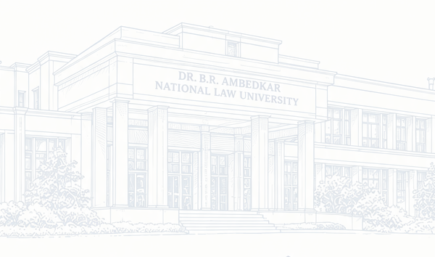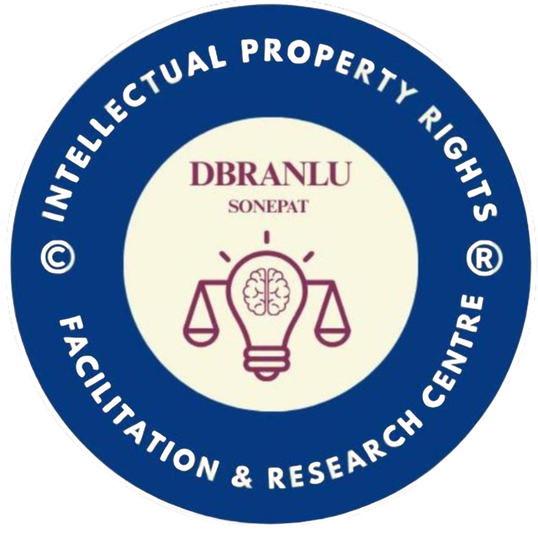About The Centre

The Centre is envisaged as an academic and research-oriented platform dedicated to promoting awareness, study and scholarship in the field of intellectual property rights and related legal developments. It seeks to encourage students and researchers to engage with intellectual property law not merely as a specialised legal subject, but as a field closely connected with innovation, creativity, commerce, technology, culture and public policy.

Through seminars, conferences, workshops, research activities, publications and academic collaborations, the Centre works to build a sustained research culture around intellectual property law, one that engages both its doctrinal foundations and its practical, real-world implications.

This centre aims to provide forums where legal scholars, practitioners, students and other stakeholders can come together to critically examine intellectual property frameworks and their capacity to respond to contemporary realities.

IPR Facilitation & Research Centre | Page 4

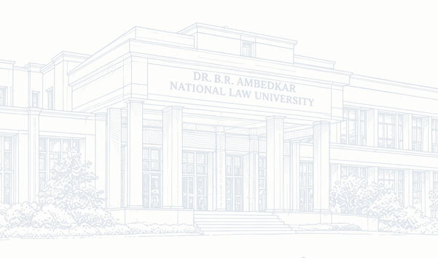ABOUT K&S PARTNERS

Founded in 1994 as a four-member firm led by Jyoti Sagar, K&S Partners has grown into one of India’s premier full-service Intellectual Property law firms. Operating as a professionally managed, meritocratic, and collegial organization, the firm was built on a vision to transform the traditional paradigm of law firm ownership. Over the past three decades, it has established a strong nationwide presence, boasting over 150 professionals spread across seven strategic offices in India.

The firm offers comprehensive legal expertise across 12 practice areas, covering the complete spectrum of IP rights—including Patents, Trademarks, Designs, Copyrights, Geographical Indications, Plant Varieties, Biodiversity, Trade Secrets, Digital Law, and IP Litigation. Supported by an extensive international network of over 1,000 global associates, K&S Partners serves a diverse portfolio of clients ranging from prominent domestic organizations to leading multinational corporations and Fortune 500 companies.

K&S Partners is anchored by its core values, summarized as "CLIPS" (Client First, Learning, Integrity, People Care, and Socially Responsible). The firm maintains a transparent, non-hereditary partnership model where partners serve as trustees dedicated to high ethical standards and client excellence. Backed by ISO 27001:2022 certification for information security and over 360 legal industry awards, the firm continues to be recognized as a trusted leader in protecting and enforcing intellectual property rights globally

IPR Facilitation & Research Centre | Page 5

Message From the Vice Chancellor

HON'BLE VICE-CHANCELLOR & PATRON-IN CHIEF

Prof. (Dr.) Devinder Singh
It gives me immense pleasure to extend my heartfelt greetings to all participants, scholars, and distinguished guests attending the National Conference on “Emerging Trends in Trademark Protection in India: Legal Enforcement and Challenges,” organised by the IPR Facilitation and Research Centre at Dr. B.R. Ambedkar National Law University, Sonepat (DBRANLU).

Trademarks lie at the intersection of commerce, technology, and law. The growth of e-commerce, social media, and artificial intelligence is transforming how brand identity is created, used, and protected. These developments call for a legal framework that keeps pace with emerging realities while safeguarding the interests of businesses, consumers, and society.

As a University committed to Dr. B.R. Ambedkar’s vision of law as an instrument of social transformation, we recognise the importance of creating spaces for meaningful academic dialogue on contemporary legal challenges. This Conference provides such a platform for examining the evolving landscape of trademark protection and enforcement in India.

I congratulate the organisers, faculty, and students of the IPR Facilitation and Research Centre and extend my best wishes for the success of the Conference. May its deliberations contribute to informed scholarship and meaningful dialogue on the future of trademark law in India.
IPR Facilitation & Research Centre | Page 6

Message From the Director

WORTHY REGISTRAR, PATRON &
DIRECTOR, IPR FACILITATION AND RESEARCH CENTRE

Prof. (Dr.) Ashutosh Mishra
It gives me great pleasure to extend my warm greetings to all participants, scholars, and distinguished guests attending the National Conference on “Emerging Trends in Trademark Protection in India: Legal Enforcement and Challenges,” organised by the IPR Facilitation and Research Centre.

The Centre is committed to fostering a sustained culture of research and academic engagement in intellectual property law, with particular emphasis on emerging doctrinal and practical challenges. In this context, the evolving trademark landscape presents important questions concerning digital commerce, online marketplaces, artificial intelligence, counterfeiting, and the changing nature of brand identity.

The Conference seeks to bring together diverse academic and professional perspectives to examine whether existing legal and enforcement mechanisms remain responsive to these developments. Through scholarly papers, expert deliberations, and focused discussions, it aims to encourage rigorous inquiry and generate research that is both academically meaningful and practically relevant.

I am confident that the Conference will contribute to deeper understanding of contemporary trademark issues and strengthen the Centre’s continuing efforts towards research-oriented engagement in intellectual property law.

IPR Facilitation & Research Centre | Page 7

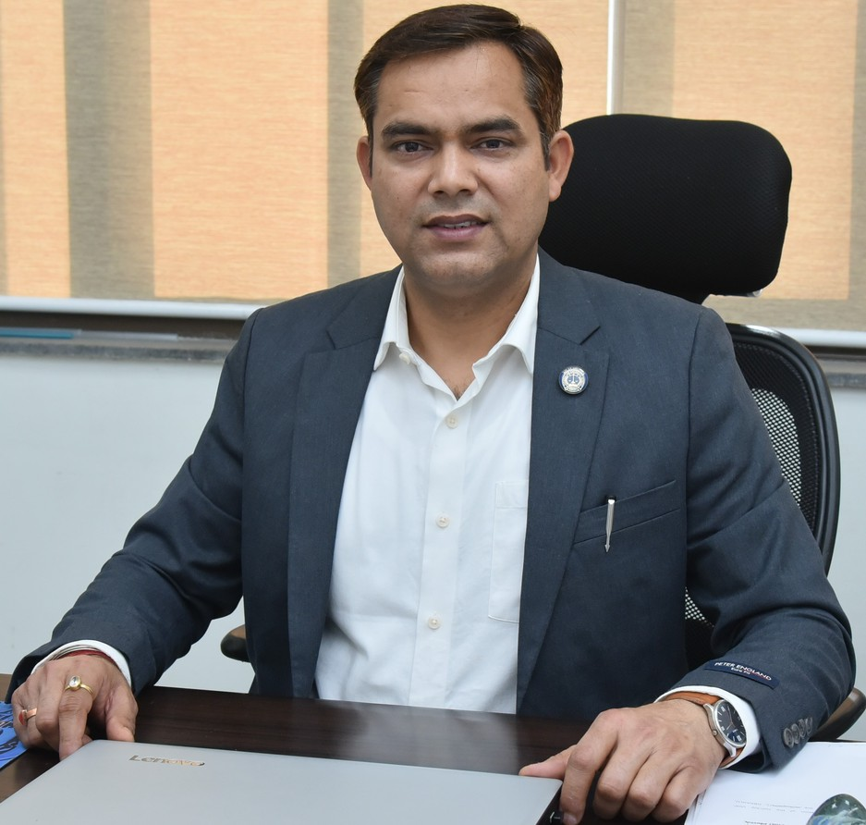Message From the Co-Director

ORGANISING SECRETARY &
CO-DIRECTOR, IPR FACILITATION AND RESEARCH CENTRE

Dr. Amit Guleria

On behalf of the student organising team, I warmly welcome our speakers, paper presenters, delegates, and guests to the National Conference on “Emerging Trends in Trademark Protection in India: Legal Enforcement and Challenges,” organised by the IPR Facilitation and Research Centre.

For many students and young researchers, trademark law begins as a subject in a textbook but becomes far more meaningful when connected with the realities of commerce, digital platforms, and everyday consumer life.

We have designed the Conference to encourage active participation and meaningful interaction between students, researchers, practitioners, and senior scholars. Engaging with diverse perspectives, presenting ideas, asking questions, and learning from professional experiences can help young researchers develop a more practical understanding of intellectual property law.

I am grateful to our Hon’ble Vice-Chancellor Sir, Worthy Registrar & Director Sir, faculty members, and fellow organisers for their guidance and support. To all our participants, thank you for being part of this academic endeavour. We look forward to thoughtful discussions, valuable learning, and meaningful connections throughout the Conference

IPR Facilitation & Research Centre | Page 8

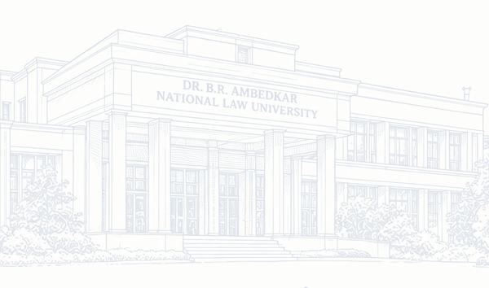About Conference

The IPR Facilitation and Research Centre is organising a National Conference on “Emerging Trends in Trademark Protection in India: Legal Enforcement and Challenges” on 31 October 2026, in hybrid mode. The Conference aims to provide an academic and research-oriented platform for academicians, practitioners, industry persons and students to examine the evolving landscape of trademark law in India.

With the rapid growth of digital commerce, social media, e-commerce, technological innovation and globalised trade, trademarks play a crucial role in protecting brand identity, consumer interests, goodwill and commercial reputation. India’s trademark framework has evolved through legislation, judicial interpretation and international developments, while facing new challenges arising from emerging commercial and technological practices.

The digital environment has introduced complex issues including online infringement, domain-name disputes, keyword advertising, social- media impersonation, counterfeit goods and misuse of trademarks in AI-generated content. The Conference will examine these challenges, the effectiveness of existing remedies, the role of courts and enforcement authorities, and the need for reforms that balance trademark protection with competition, consumer interests and freedom of expression, while drawing on landmark Indian and comparative judicial decisions.

IPR Facilitation & Research Centre | Page 9

about theme & sub - themes

Theme:
Emerging Trends in Trademark Protection in India: Legal Enforcement and Challenges
The Conference will further provide an opportunity to revisit landmark judicial decisions that have shaped Indian trademark jurisprudence and to critically assess emerging judicial approaches to trademark protection and enforcement. Through research paper presentations, expert deliberations and interactive academic sessions, the event aims to identify contemporary challenges, emerging trends and possible avenues for legal and policy reform.

Proposed Sub-Themes

- Trademark Infringement in the Digital Marketplace
Examines how online platforms, marketplaces and search engines have transformed the scale and nature of infringement, and the legal and technological responses available to rights holders.

- Domain Names, Cybersquatting, and Online Brand Identity
Considers disputes arising from domain-name registration, cybersquatting and the protection of brand identity in online spaces, including the adequacy of existing dispute-resolution mechanisms.

- Well-Known Marks and Cross-Border Reputation
Explores the recognition and protection of well-known trademarks, and the challenges of establishing cross-border reputation and dilution in an increasingly globalised marketplace.

- Non-Traditional Trademarks: Scope and Registrability
Analyses the legal treatment of shapes, sounds, colours, scents and other non-traditional marks, and the evidentiary and doctrinal challenges involved in their registration and protection.

IPR Facilitation & Research Centre | Page 10

about theme & sub - themes

- AI, Deepfakes and the Intersection of Trademark and Personality Rights Investigates emerging questions at the intersection of trademark law, personality rights and artificial intelligence, including the unauthorized use of marks and identities in generated content.

- Judicial Trends in Passing Off and Injunctive Relief
Reviews how Indian courts have approached passing-off actions and interim injunctive relief, and identifies emerging trends in judicial reasoning and remedies.

- Trademark Enforcement Mechanisms: Criminal, Civil, and Administrative Remedies
Assesses the effectiveness of the criminal, civil and administrative remedies available for trademark enforcement, and the practical challenges in invoking them.

- Globalisation and the Future of Indian Trademark Law
Considers how international trade, treaty obligations and comparative developments are shaping the future direction of Indian trademark law and policy.

- Olfactory Marks: Scope and Registrability
Examines the registrability of olfactory (scent) marks under Indian trademark law, the difficulties of graphical and objective representation, and comparative approaches adopted in other jurisdictions.

- Collective Marks: Legal Framework and Contemporary Issues
Explores the registration, use and enforcement of collective marks by associations and groups of producers, and the challenges involved in maintaining collective control, quality and reputation.

- Slogan Marks: Protectability and the Limits of Distinctiveness
Considers the registrability of slogans and taglines as trademarks, the threshold of distinctiveness required, and judicial approaches to protecting advertising phrases from imitation.
IPR Facilitation & Research Centre | Page 11

about theme & sub - themes

- Certification Marks and Quality Assurance in Trade
Considers the role of certification marks in assuring product quality, standards and origin to consumers, and examines the regulatory framework and enforcement challenges associated with their use and misuse.

- Sound Marks and the Recognition of Auditory Brand Identity Examines the registrability of sound marks under Indian trademark law, the requirement of graphical representation of a sonic trademark, and the evidentiary challenges involved in establishing distinctiveness for auditory brand identity.

NOTE: The Conference invites research papers on the above- mentioned sub-themes and related areas. The sub-themes are indicative and not exhaustive, and contributions addressing other relevant topics and interdisciplinary papers that meaningfully engage with more than one sub-theme are also welcome.

IPR Facilitation & Research Centre | Page 12

Aims & Objectives

The principal aim of the Conference is to facilitate research-based academic discourse on the evolving framework of trademark protection in India, with particular emphasis on emerging trends, legal enforcement mechanisms and contemporary challenges. In pursuing this aim, the Conference seeks to bring doctrinal scholarship into conversation with the practical realities faced by businesses, consumers, practitioners and enforcement authorities.

The objectives of the Conference are:

- To deepen understanding of the core doctrines and statutory framework governing trademark protection in India, including registrability, ownership and the scope of rights.

- To examine emerging developments in Indian trademark case law and statutory reform, and how courts and the legislature are shaping the field.

- To critically analyse the effectiveness of existing mechanisms for trademark enforcement, including civil, criminal and administrative remedies.

- To assess the impact of e-commerce, social media, digital advertising and emerging technologies on trademark protection and infringement.

- To explore contemporary issues relating to well-known trademarks, dilution, passing off and unfair competition.

- To examine the legal status of, and challenges in protecting, non-traditional marks such as shapes, colours, sounds and smells.

- To bring academicians, practitioners, policymakers and students together to discuss the future of trademark law and policy in India, while giving early- career researchers a platform to present original work and receive constructive feedback.

IPR Facilitation & Research Centre | Page 13

Submission and Registration Guidelines

All participants shall be required to complete the official registration process within the notified timeline. Participants shall be required to submit an abstract in accordance with the Call for Papers. Abstracts shall be screened for relevance and academic quality, and selected abstracts shall be given the opportunity to present at the Conference.

Participants whose abstracts are selected for presentation shall thereafter be required to complete the registration process, including payment of the applicable registration fee, within the notified timeline. The selected participants shall also be required to submit the full paper by 26.01.2027. The registration fee, where applicable, shall be paid through the notified mode of payment.

Confirmation of participation shall be subject to receipt of the required registration details and fee. Further instructions concerning paper format, presentation time, certificates, publication opportunities and online participation shall be communicated through the official Conference notice.

Selected papers will be published in the Conference proceedings and no additional charges will apply for publication. Authors are advised to retain a copy of their submission and payment receipt for future reference, and to regularly check the official communication channel for updates regarding the review process.

NOTE : All registered participants are required to present their papers based on their abstracts during the conference proceedings on 31 October, 2026.

IPR Facilitation & Research Centre | Page 14

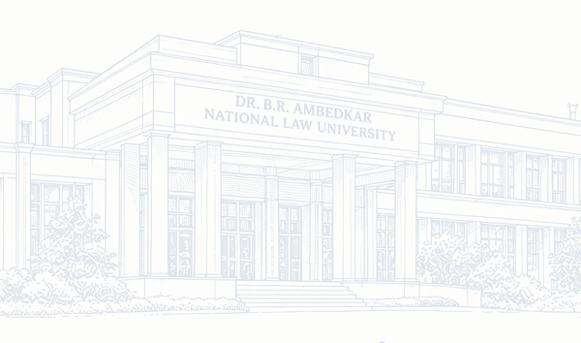Registration Fee

The registration fee generally covers access to all technical sessions, conference kit, working lunch and refreshments for offline participants, and a soft copy of the Conference proceedings for presenters whose papers are selected for publication.

Co-Authorship

Papers with up to two authors are permitted. Where a paper has two authors, both are required to register individually under the applicable “Co-author / Double” fee, and both will be eligible for a certificate of presentation upon successful participation in the conference.
CATEGORY | SINGLE AUTHOR | CO AUTHOR  /DOUBLE
DBRANLU Students | ₹200 | ₹300
Students from other Institutions | ₹600 | ₹800
Academicians & Industry Persons | ₹1000 | ₹1200
IPRFRC Team & Volunteers | ₹150 | ₹200

Note: The fee is to be submitted only after communication of acceptance of the abstracts. The acceptance will be communicated through the official email address provided by the participants at the time of abstract submission.

IPR Facilitation & Research Centre | Page 15

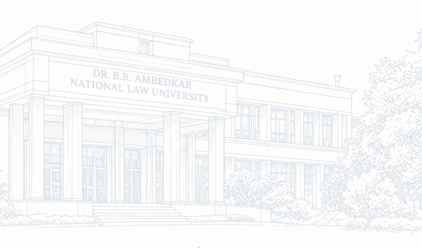 Abstract Submissions

- Authors are invited to submit abstracts on the themes of the conference. Each abstract should be original and unpublished. Submissions must be sent in Docx. format through the Abstract Submission link on or before the last date i.e 21.10.2026
- All submitted abstracts will be reviewed by the Editorial
Committee for relevance to the theme, originality, clarity, and quality of research. The decision of the committee shall be final.
- Authors whose abstracts are selected will receive an
acceptance email on the email ID provided at the time of submission.
- Registration will open only after the acceptance email is
received. Authors who do not complete registration within the stipulated time after acceptance may lose their slot.

ABSTRACT SUBMISSION

LINK https://forms.gle/HNcxpfh4rupKkiPZ8 QR CODE

Payment Details
For the Payment of the Registration Fees-
Account Name : REGISTRAR DBRANLU RAI
Account Number : 50100156483861 IFSC Code : HDFC0003433

IPR Facilitation & Research Centre | Page 16

Guidelines for Submission

- Word Limit
The research paper must be between 6,000-7,500 words (excluding footnotes). The prescribed word limit must be strictly adhered to.

- Plagiarism
The permissible plagiarism for the research paper is up to 10%. Authors are advised to ensure that their submissions are original and must reflect upto 5% AI- Generated Content only, subject to verification through an AI- Detection mechanism.

- Formatting Guidelines
The research paper must conform to the following formatting requirements:
Font: Times New Roman
Font Size for Main Content: 12 Font Size for Headings: 14 Line Spacing: 1.5
Paragraph Spacing: 1.5
Footnote Font Size: 10
Footnote Spacing: 1

- Citation Style
All citations and references must strictly follow 22nd edition of the Bluebook.

- General Requirement
Authors are requested to carefully adhere to all the above-mentioned guidelines. Papers that do not comply with the prescribed word limit, plagiarism threshold, formatting requirements, or citation style may be subject to rejection or revision.

IPR Facilitation & Research Centre | Page 17

Awards and Recognition

To recognise outstanding research and presentations, the Conference shall have the following awards:

AWARD | ELIGIBILITY | POSITION | PRIZES
Best Presenter | UG/PG | 1st | Internship at K&S Partners (to be undertaken in March/April)
Best Presenter | UG/PG | 2nd | ₹ 2100/-
Best Presenter | UG/PG | 3rd | ₹ 1100/-
Best Presenter | Academicians / Ph.D. / Industry Persons | 1st | ₹ 5100/-
Best Paper | All Categories Combined | 1st | ₹ 3100/-

Note: The above awards are tentative and subject to further change by the Organising Committee. All award winners will also receive an E-Certificate of Merit in addition to the prizes listed above.
All Pariticipants shall recieve an E- Certificate of Participation.

IPR Facilitation & Research Centre | Page 18

Timeline

Brochure Release

07.10.2026

Acceptance of Abstracts & Commencement of Registrations

24.10.2026

Day of Conference

31.10.2026

Submission of Abstracts

21.10.2026

Final Date of Registrations

26.10.2026

Communication of Acceptance of
Full Paper

17.02.2027
Final Date of Paper Submission

26.01.2027



IPR Facilitation & Research Centre | Page 19

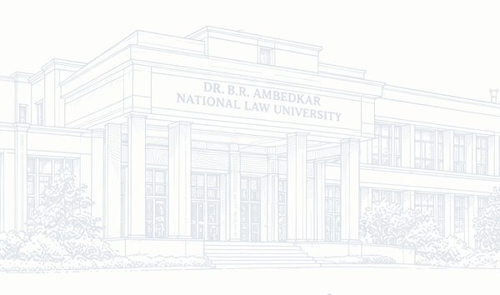Contact Us

Official Mail: iprfrc@dbranlu.ac.in

Contact No. :
Areesha : +91 91125 14849
Nischay : +91 84100 32880
Dhamini : +91 81783 35445
Vipula : +91 92531 94996

All communications, queries, and updates will be communicated through the official mail ID or these contact numbers only.

ADDRESS: Dr. B.R. Ambedkar National Law University, Sonepat, Plot No. 5, Rajiv Gandhi Education City, Rai,Sonipat (Haryana)- 131029

IPR Facilitation & Research Centre | Page 20

