INSTRUCTIONS

- Fill all the details carefully.
- Navigate to the official event portal: https://rgnul.lsacademia.in/lsa_rgnul/eventPortal/loginFrom.jsp.
- Be extremely careful when selecting your competition from the “Applying For” dropdown menu; if you choose the wrong event category, your application will be strictly rejected.
- From the dropdown options, select the 3rd National IP Article Writing Competition, 2026.
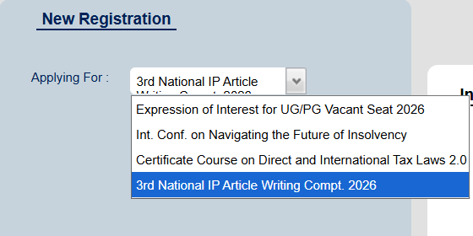
- In the Details section, fill out all mandatory fields accurately, including Name of the Participant, Designation, Name of Institute/College, Mobile No., Email ID, and select the appropriate Registration Fee from the dropdown menu.
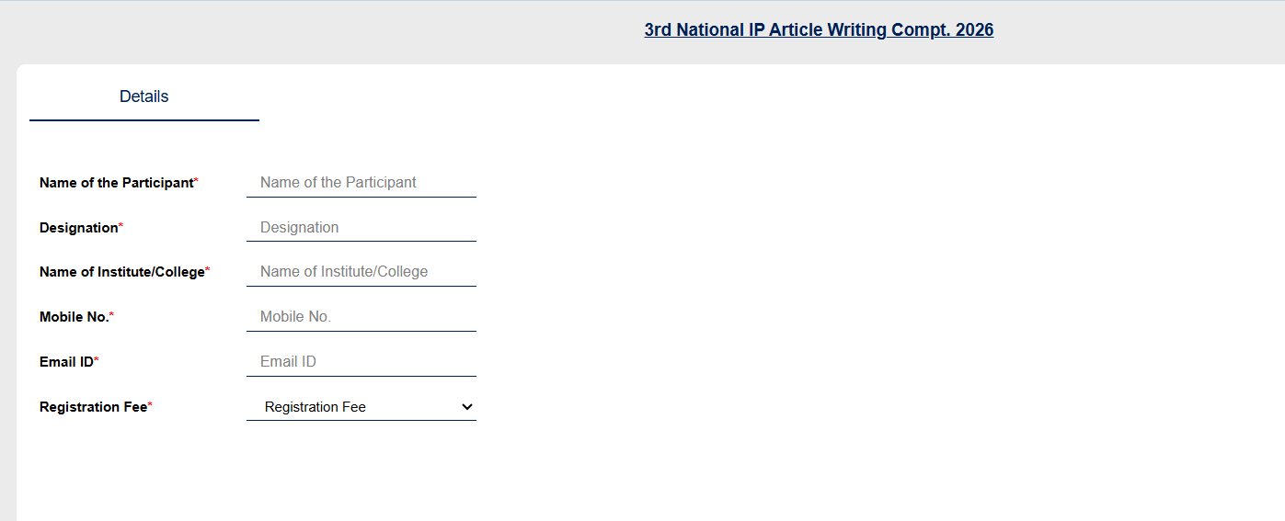
- Once the form is filled out successfully, a confirmation message will appear on the screen. Please note down your system-generated Registration Number displayed in the green text (e.g., 2025027241).
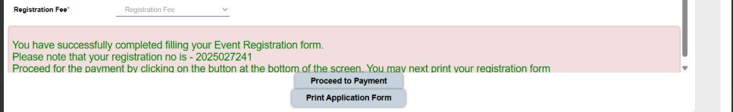
- Click the “Proceed to Payment” button at the bottom of the screen to launch the payment gateway. Do not close or refresh the browser window while the transaction is processing.
- After completing the payment, click the “Print Application Form” button to download and save a copy of your final registration for your records.
- Please note that the registration fee will not be refunded in any case.

